**Project Report On**

**JOB PORTAL**

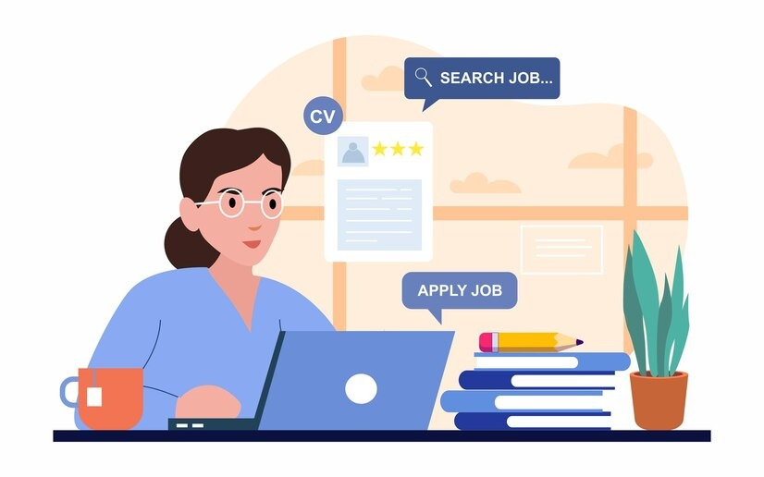

**As partial fulfilment of**

**Bachelor of Computer Application**

**[T.Y.B.C.A]**

**Submitted to,**

**MATRUSHRI VIRBAIMA MAHILA COLLEGE OF COMMERCE MGMT. & IT.**

**Affiliated to,**

**SAURASHTRA UNIVERSITY, RAJKOT**

**Project Guide: Mr. Niraj Tanna**

**Submit By: Mayushi Girishbhai Ramani [21bca102]**

**Krishna Dineshbhai Padaliya [21bca086]**

**Rutva Dikeshbhai Sorathiya [21bca124]**

**Index**

|  |  |  |
| --- | --- | --- |
| **Sr No.** | **Title** | **Page No.** |
| 1 | Justification Of Title |  |
| 2 | Preface |  |
| 3 | Acknowledgement |  |
| 4 | Project Profile |  |
| 5 | Technology Study   * About Front Side * About Back Side |  |
| 6 | Timeline Chart |  |
| 7 | SDLC Stage Implementation  Preliminary Investigation  System Analysis  System Design  A] Data Dictionary  B] DFD/Data Flow Diagram  C] ER Diagram  D] Normalization |  |
| 8 | Client Site |  |
| 9 | Admin Site |  |
| 10 | System Testing |  |

Approval of Title

**“JOB PORTAL”**

The days of walk-in application for jobs have passed. People no more queue up to getting a meeting with a recruiter and hand them their resume personally. While it requires a lot of space and time, that process is just not efficient enough.

While now that we have the technology to support our businesses, it has also proven a helpful tool in conducting job searches. Today, most of the leading companies have their own dedicated job portals that help them conduct the recruitment process without hiccups. Job portals are online platforms that provide job boarding solutions and helps job seekers to apply for posts that they are suitable for.

Job portals, also known as career portals, are modern versions of job boards. These sites allow job seekers to post their applications online and apply to posts which they deem suitable to their career track. Similarly, it also lets firms review posted resumes and find qualified candidates for the job. Job portals also make it possible for firms to reach as much candidates as possible for their job vacancies.

Popular job board software like Monster and Naukri provide an open-ended job portal where all companies can post their job vacancies, and candidates can choose from a comprehensive list of options. However, many top tiring companies have started to create their own job portals to attract viable candidates and conduct their recruitment process.

It is an excellent model for an organization to locate ideal candidates for various job positions and helps consolidate their resumes. In addition, it enables them to extend their reach and find the best candidate for their vacancy.

Preface

We would like to state that the project is very essential part of our education portion.

We are honour to presenting this project report in **BCA semester 5th at MATRUSHRI VIRBAIMA MAHILA COLLEGE OF** **COM., MGT & IT.** The topic of project is **“Job portal”.** This preface shows highlight of our project so, you can give your valuable review is to us.

We made this file because, if any non-technical person read this, they can understand that we are mentioned over here.

Project report is just outstanding experience for us. Because we learn that how to explain our point of view in front of all audience which are came from non it backgrounds. We learn the easy and simple language that all the audience can understand our motive.

By preparing this project we have understood the need of practical training in the education field.

**Acknowledgment**

It was a great pleasure working on Online **JOB PORTAL** which is donesemester 5th of B.C.A. We would like to mention here that this project would not possible without the support and guidance of our professors.

As the final frontier toward achieving a **B.C.A.** the activity of going through IT project has bridge the gap between the academic and practical real-life work for us. It has prepared us to apply ourselves to become good IT professional.

On the even of completion of our project regarding **JOBPORTAL**.

The project has been prepared by us. This is good opportunity to shows our codding talent which was learn by us during our whole journey of our B.C.A degree.

Our faculties are extremely good. They are guide us for our project as well as study. Our project guide (MR. NIRAJ TANNA) help us through their suggestions.

PROJECT PROFILE

Project title: JOB PORTAL

SSD used: 512GB

Operating system: Windows 10

Front end: PHP

Back end: My SQL

Documentation tools: Microsoft Word

Project guide: Mr. Niraj Tanna

Project duration: 3 Month

Submitted by: Padaliya Krishna

Ramani Mayushi

Sorathiya Rutva **Technology Study about Frontend**

**\*HTML:**

HTML is a computer language devised to allow website creation. This website ca then we viewed by anyone else connected to the internet. It is relatively Easy to learn with the basic being accessible to most people in one sitting; and quite Powerful in what it allows you to create.

It is constantly undergoing revision and evolution to meet the demand and requirement of the growing. Internet audience under the direction of the W3C, The organization charged with designing.

HTML is the standard mark-up language for creating webpage.

HTML stands for Hyper Text Mark-up Language.

HTML describe the structure of web pages using mark-up.

HTML element are the building blocks of HTML pages.

HTML elements are represented by tags.

HTML tags label piece of content such as “Heading”,” Paragraph”,” Table” and so on.

**\*PHP:**

1. What is PHP?

PHP is an uncronum for “PHP: Hyper Text Pre-Processer”:

PHP is widely used, open source language.

PHP script are executing on server.

PHP is a free to download and use.

2. What is PHP File?

PHP file can content TEXT, HTML, CSS, JAVA script and PHP code.

PHP code are executing on server and then result is return to browser as plain HTML.

PHP file have extension “.PHP”.

3. What can PHP do?

With PHP you are not limited to output.html you can output images. PDF and even flash moving you can also output any text such as XHTML & XML.

PHP can generate dynamic page content.

PHP can create, open, read, write, delete and close file on server.

PHP can be used to control user access.

PHP can send and receive cookies.

4. Why PHP?

PHP run for various plate form [Windows, Linux, UNIX, macros, etc...]

PHP is compatible with almost all server used today [apache, IIS, etc...]

PHP support wide range of database.

PHP support wide is a free download it from the official PHP records: [WWW.PHP.net](http://WWW.PHP.net).

PHP is an amazing and popular language!

It is a powerful enough to be at the core of the biggest blog system on the web [WordPress]!

It is a deep enough to run the largest social network [Facebook].

It is also very easy enough to be beginner’s first server-side language!

**\*JAVA SCRIPT:**

A java script file is used mainly to run client side. Java script code on webpage and its extension is Java script.

The Java script file contain all the HTML HEAD and BODY objects in the tag of HTML page.

Java script is used in web development to do such things are:

1] Automatically change a formatted data.

2] cause a linked-to-page to pop-up in a new window.

3] Cause text are image to change during a mouse rollover.

Despite the name Java script is essentially unrelated to Java programming, through both have the common copies [Syntax and Java Script] many Java names and naming conversions.

The language was renamed from live script in co-marketing deal between Netscape and sun in exchange for Netscape bundling sun’s Java run time with three browsers.

The key design principle within java script inherited from the self-programming language.

**About Back End**

**\*MY SQL:**

1. What is database?

Database is separate application the store a Collection of Data.

Each database has one or more distinct APPIs for creating accessing managing searching and replicating that data it holds.

2. What is RDBMS?

We use Relational Database Management System (RDBMS) to share and manage huge volume of data.

This is called relational because all the data is store info different tables and relations are establish using primary key.

* MY SQL Database:

My SQL is fast, easy to use RDBMS being used for many small and big business.

My SQL is developed marketed and supported by MySQL dB, which is Swedish company, MySQL is become so popular because of many good reasons:

1] It is release under on Open Source License so you have nothing to pay to use it.

2] It is very powerful program in its own right. It is hand able a large subset of the functionality of the most expensive database package.

3] It use standard form of the well-known SQL data language.

4] It works on many operating system and with many languages including PHP, PERL, C, C++, JAVA, etc…

5] It works quickly and work well even with large data set.

6] It is support large database, up to 50 Million row or more in a table.

7] Default file size limit for table is but you can increase this [if your operating system can handle it] to a theorical limit of terabytes.

8] It is customized the open source allows programmer to modify the MySQL to fit their own specific environment.

9] It is a very friendly to PHP most appreciated language for web development.

Web

PHP

Obtain Data Dynamic Page

My SQL

Web Browser

PHP

File

Page Request

MYSQL the most popular data open source SQL Database Management System is developed distributed and support by MYSQL AB.

MYSQL AB is commercial company, founded by the MYSQL developers.

**Time Line Chart**

|  |  |  |  |  |
| --- | --- | --- | --- | --- |
| Task No | Task Name | Start Date | End Date | Duration |
| 1 | Preliminary Investigation | 19-6-2023 | 30-6-2023 | 12 days |
| 2 | System Analysis | 1-7-2023 | 15-7-2023 | 16 days |
| 3 | System Design | 16-7-2023 | 31-7-2023 | 16 days |
| 4 | System Development | 1-8-2023 | 25-8-2023 | 26 days |
| 5 | Testing | 26-8-2023 | 2-9-2023 | 8 days |
| 6 | Implementation | 3-9-2023 | 9-9-2023 | 7 days |
| 7 | Final Testing | 10-9-2023 | 15-9-2023 | 6s days |

**Chart:**

**SDLC Stage wise Implementation**

1. **Preliminary Investigation: -**

A] Information Gathering:

For getting job portal related information we checked many job-related websites and gather information about this website.

B] Requirement Analysis:

Requirement Analysis is critical to the success or failure of system software project.

C] Physibility Study:

**Technical Physibility:**

This phase gives technical information about used hardware and software in our project.

1. **Editor:** Sublime
2. **Browser:** Google
3. **Server:** Apache
4. **Back end:** my SQL
5. **Front end:** PHP
6. **RAM:** 4.00 GB
7. **Hard Disk:** 1 TB
8. **Processor:** Intel(R) core (TM) i5-10400
9. **Screen:** 17 inches
10. **Device:** Mouse, Keyboard,Desktop

Economical physibity:

This phase is given information about hardware and software which was used in our project.

1. **Software use:** Microsoft academic alliance campus license all Microsoft products.
2. **Software price:** 15,000 RS
3. **Hardware price:** 18,000 RS
4. **Operating system:** Windows 10

* Request Approval:

Analysis approved the demand of user and ready to developed the project.

We can go through the investigation process and agree to developed the project.

.

**2] System Analysis: -**

**A] Manual System:**

In manual system we need to explain about Job portal information.

**B] Proposed System:**

In propose system any job seeker visit to our website.

If any job seeker came to the website they gain a true information about any jobs.

If information is wrong our impression is might be wrong Infront of them.

**3] System Design: -**

A] Data Dictionary: -

A data dictionary is a collection of names, definition is attributes about data elements that are being used or captured in a database, information system or part of a research project.

Data Dictionary is set of information describe the contents, format and structure of database.

Designer selects file structure and storage devices.

**about**

|  |  |  |
| --- | --- | --- |
| **Name** | **Data Type** | **Value/length** |
| A_id | Int | 20 |
| Title | Varchar | 20 |
| Image | Varchar | 20 |
| Des | Long text | 20 |

**Category**

|  |  |  |
| --- | --- | --- |
| **Name** | **Data Type** | **Value/length** |
| c_id | Int | 20 |
| c_nm | Varchar | 20 |
| C_img | Varchar | 20 |

**Subcategory**

|  |  |  |
| --- | --- | --- |
| **Name** | **Data type** | **Value/length** |
| c_id | Int | 20 |
| s_id | int | 20 |
| s_nm | Varchar | 20 |
| S_img | varchar | 20 |

**Product**

|  |  |  |
| --- | --- | --- |
| **Name** | **Data type** | **Value/length** |
| p_id | Int | 20 |
| s_id | int | 20 |
| p_nm | Varchar | 20 |
| p_img | varchar | 20 |

**Admin**

|  |  |  |
| --- | --- | --- |
| **Name** | **Data type** | **Value/length** |
| id | Int | 10 |
| Name | varchar | 111 |
| Email | Varchar | 111 |
| Password | varchar | 111 |

**User**

|  |  |  |
| --- | --- | --- |
| **Name** | **Data type** | **Value/length** |
| id | Int | 10 |
| User Name | varchar | 111 |
| Email | Varchar | 111 |
| fname | varchar | 111 |
| lname | varchar | 111 |
| mno | int | 111 |

**Job**

|  |  |  |
| --- | --- | --- |
| **Name** | **Data Type** | **Value/length** |
| Id | Int | 10 |
| Job_name | Varchar | 111 |
| des | Varchar | 200 |

**Feedback**

|  |  |  |
| --- | --- | --- |
| **Name** | **Data type** | **Value/length** |
| f_id | Int | 10 |
| f_nm | Varchar | 30 |
| Email | Varchar | 50 |
| City | Varchar | 20 |
| Subject | Varchar | 25 |
| msg. | Varchar | 200 |

**Reg-form**

|  |  |  |
| --- | --- | --- |
| **Name** | **Data type** | **Value/length** |
| u_id | Int | 20 |
| u_nm | Varchar | 111 |
| U_lnm | Varchar | 111 |
| Password | Varchar | 111 |
| Cpwd | Varchar | 111 |
| dob | Varchar | 10 |
| gender | Varchar | 10 |
| address | Varchar | 111 |
| city | Varchar | 100 |
| state | Varchar | 100 |
| Email | Varchar | 100 |
| Ph_name | int | 15 |

**Resume**

|  |  |  |
| --- | --- | --- |
| **Name** | **Data type** | **Value/length** |
| u_id | Int | 20 |
| u_nm | varchar | 20 |
| f_nm | Varchar | 20 |
| l_img | varchar | 20 |
| document | varchar | 30 |

**Data Flow Diagram**

It is a graphical representation of the “FLOW” of data. Through an information system, modelling this process aspect.

The DFD is also known as bubble chart. Where use processing carried out on the data, and the output Data generated by the system.

The main reason DFD technique is so popular is on the account of the fact, that it is very simple to use and understand.

It can be used for the visualization of data processing.

It show a what kind of information will be input to and output from the system, How the data will advance through the system and where the data will be stated.

It does not show information about process timing or whether process will operate in sequence or in parallel. Unlike a traditional structured flow chart which focus on control flow, or unit activity and data flow as a unified model.

**\*Advantages of Data Flow Diagram:**

It helps us to understand the functionality and the limits of a system.

It is used as a part of system documentation file.

**\*Disadvantages of Data Flow Diagram:**

At times DFD can confused the programmers regarding the system.

Data Flow Diagram takes long time to be generated and many times due to this reasons analysis are denied permission to work on it.

**\*Following symbol are used in DFD:**

|  |  |  |  |
| --- | --- | --- | --- |
| **No** | **Symbol** | **Name** | **Description** |
| 1 |  | Arrows | The Flow Of Data between data stores. External entities and processes. |
| 2 |  | Circles | A process manipulates data. |
| 3 |  | Open-End Boxes | Data stores or place where data is held temporarily or permanently. |
| 4 |  | Square | External entities such as people or other systems that feed data from the systems remove the person from the box. |

* **Step to create DFD:**

1. Create a list of activates.
2. Construct context level DFD.
3. Construct 0 level DFD.
4. Construct 1 level DFD.
5. Check again rules of DFD.

* **List of activities in our project:**
* **List of activities in our project:**

User registration

Add/edit/delete category

Add/edit/delete subcategory

Add/edit/delete about us details

Add/edit/delete feedback details

View user-info details

View feedback details

* **Context diagram :**

**ADMIN**

**VISITOR**

**USER**

* **Zero Level DFD:**

**ADMIN**

**USER**

Login & logout logout &

Login

**Level 1 User DFD:**

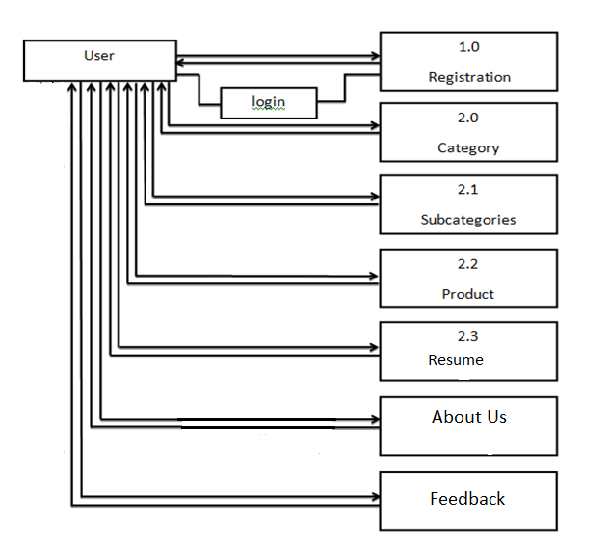

**Level 1 Admin DFD:**

FEEDBACK

JOB

User

Admin

**\*ER Diagram:**

ER Diagram stand for entity relationship diagram, it show the represition of entities, attributes sets and its attributes.

**\*Entity:**

An entity can be any object, cart, user or bill in ER Diagram. Entity can be represented using rectangle. Consider an example of entities on our project [reg_form, admin, category, subcategory, product, cart, feedback, bill, contact_us, about us, checkout] .

**\*Attributes:**

Attributes describes property or charactistic of an entity, In ER Diagram entity can be represented using elipse. Consider example of attributes in our project. [c_id, c_nm, c_img] for entity [category] .

**\*Relationship:**

A relationship describes relations between entities, it can replace by diamond shapes and are connected by a line.

**1] one to one:**

This type of relationship means one entity is associated with one number of some entity. This type of relationship is rearly seen in real world.

**2] one to many:**

This type of relationship means are 1 entity is associated with many number of some entity.

**3] many to many:**

This type of relationship means many entity is associated with many number of same entity.

ER Diagram is a graphical method representing entity classes, attributes and relationship.

**\*An ER Diagram used six basic symbols:**

|  |  |  |
| --- | --- | --- |
| 1 | Rectangle: | Rectangle to donote any entity text. |
| 2 | Diamond: | Diamond to donote relationship between two entities. |
| 3 | Oval: | Oval to donote attribute. |
| 4 | Line: | Line which link attribute to entity or entity set and entity set two to relationship. |
| 5 | Single:  1 | ‘1’ to donotes single to occurrence. |
| 6 | Multiple:  M | ‘M’ to donotes multiple occurence. |

**\*ER Diagram:**

**REGISTRAION**

**has**

**SUBCATEGORY**

**has**

**PRODUCT**

**has**

**RESUME**

**\*ER Diagram:**

**REGISTRAION**

**has**

**CATEGORY**

**SUBCATEGORY**

**has**

**has**

**PRODUCT**

**has**

**RESUME**

**Admin**

**About us**

**feedback**

**Normalization**

Normalization is the process of organizing the columns and tables or relational database to reduce data redundancy and improve data.

It is also the process of simplifying the design of database so that optimal database structure.

It was first proposed by edger, codd. As an integral part of relational model.

It involes arranging attribute in relation based on dependencies between attributes, ensuring that the dependencies are properly enforced by database integrating constratiants.

It is accomplished by applying some formal either by process of synthesis or decomposition.

Edger fcodd the inventor or the relational model (RM). Introduced the concept of normalization.

**1] First Normal Form (INF):**

It is a property of relation in a relational database.

A relation is in First Normal Form if any only if the domain of each attributes contains only invisible values and the value of each attribute contains only single value from the domain.

* **First Normal Form enforces these criteria:**

Eliminates repeating group in individual tables.

Create a separate table for each set of related data.

Identify each set of related data with a primary key.

* **The process by which we efficiently organized data to achieve goals:**

1. Eliminating Redundancy
2. Ensuring data is stored in correct table.
3. Eliminating need for restructure database when data is added.

Category

|  |  |  |
| --- | --- | --- |
| **C_id** | **C_nm** | **C_img** |
| 1 | online | Job.jpg |
| 2 | offline | job.jpg |

Subcategory

|  |  |  |  |
| --- | --- | --- | --- |
| **C_id** | **S_id** | **S_nm** | **S_img** |
| 1 | 1 | Full stack development | Job1.jpg |
| 2 | 2 | Full stack development | Job2.jpg |

**2] Second Normal Form (2NF):**

It is normal form used in database normalization.

Relation that is in 1nf must meet additional criteria if it is to qualify for second normal form.

**Specially:**

Relation is in 2nf if it is in 1nf and no non-prime attribute is dependent on any proper subset of any candidate key of relation.

Non-prime attribute of relation is an attribute that is not a part of any candidate key oh the relation.

|  |  |  |  |
| --- | --- | --- | --- |
| **P_id** | **S_id** | **P_nm** | **P_image** |
| 1 | 1 | PHP | Php.jpg |
| 2 | 1 | JAVA | Java.jpg |
| 3 | 1 | HTML | Html.jpg |
| 4 | 2 | HTML & CSS | Css.jpg |
| 5 | 2 | BOOTSTRAP | Boot.jpg |
| 6 | 2 | PYTHON | Python.jpg |

product

**3] Third Normal Form (3NF):**

Third Normal Form is a normal form that is in used in normalization a data design to reduce the duplicate of data and ensure referential integrate by insure that.

1. The entity is in second normal for and.
2. All the attributes in a table are data remind only by the candidate key of that relational and not by any non-prime attributes.

3NF was designed to improve database processing while minimizing storage cast.

3NF data modeling was ideal for online transaction processing (OLTP) application with heavy order enter type on needs.

**4] Byoce – Codd Normal Form (BCNF):**

Boyce-Codd Normal Form (or BCNF or BSNF) is a normal form used in database normalization.

It is slightly stranger version of the 3 Normal Form (3NF).

BCNF was developed to address certain types of anomalies not default with by 3NF as originally defined.

If a relational schema is in BCNF then all redundancy has been on functional dependency has been removed, although other types of redundancy may still exist.

**Client Side**

**Task:1** Make Header and Footer



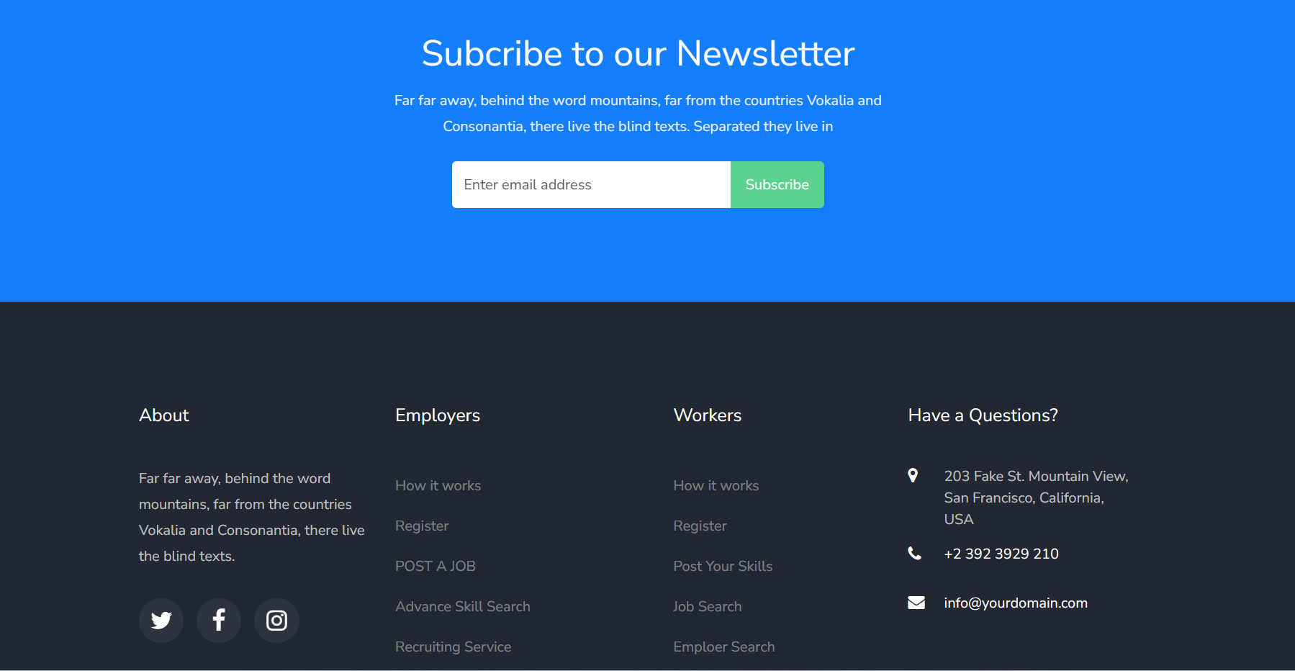

**Task: 2**  Make link in Header and link page



**HOME**

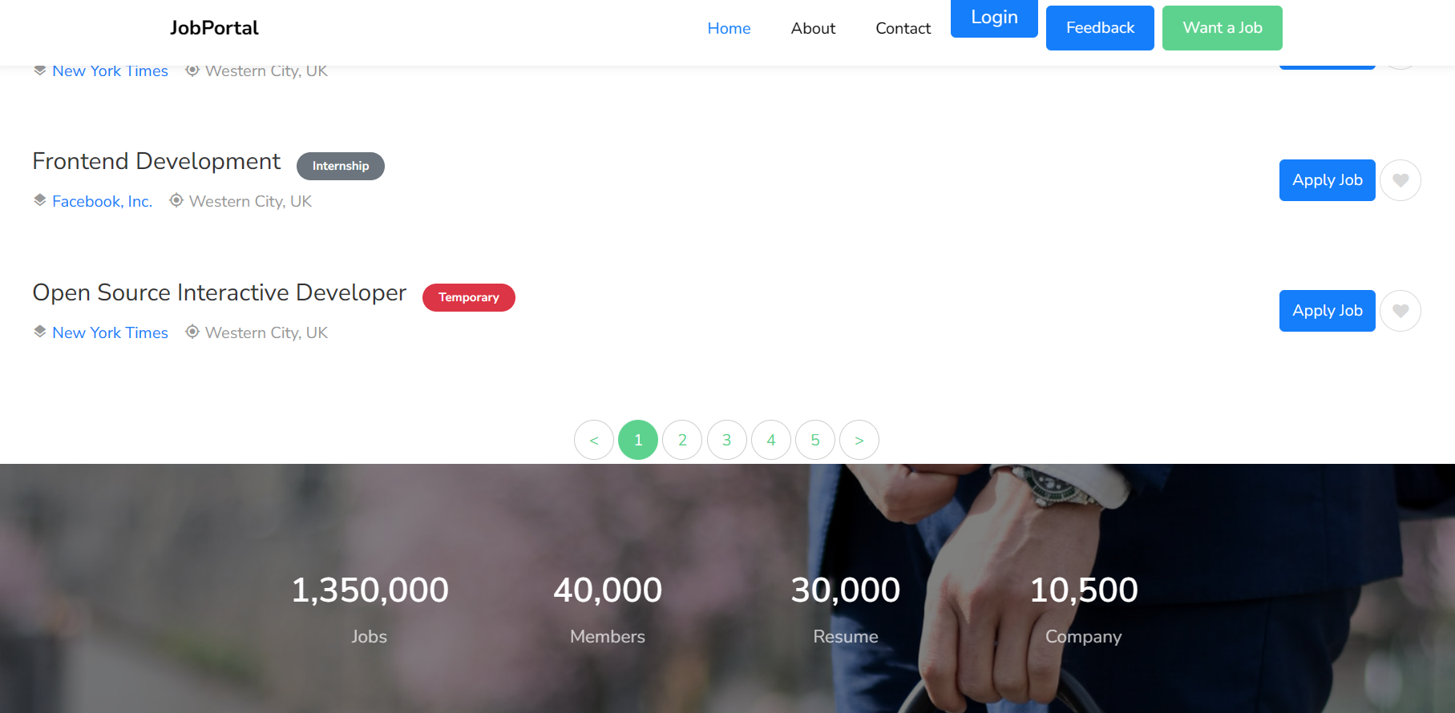

**ABOUT US**

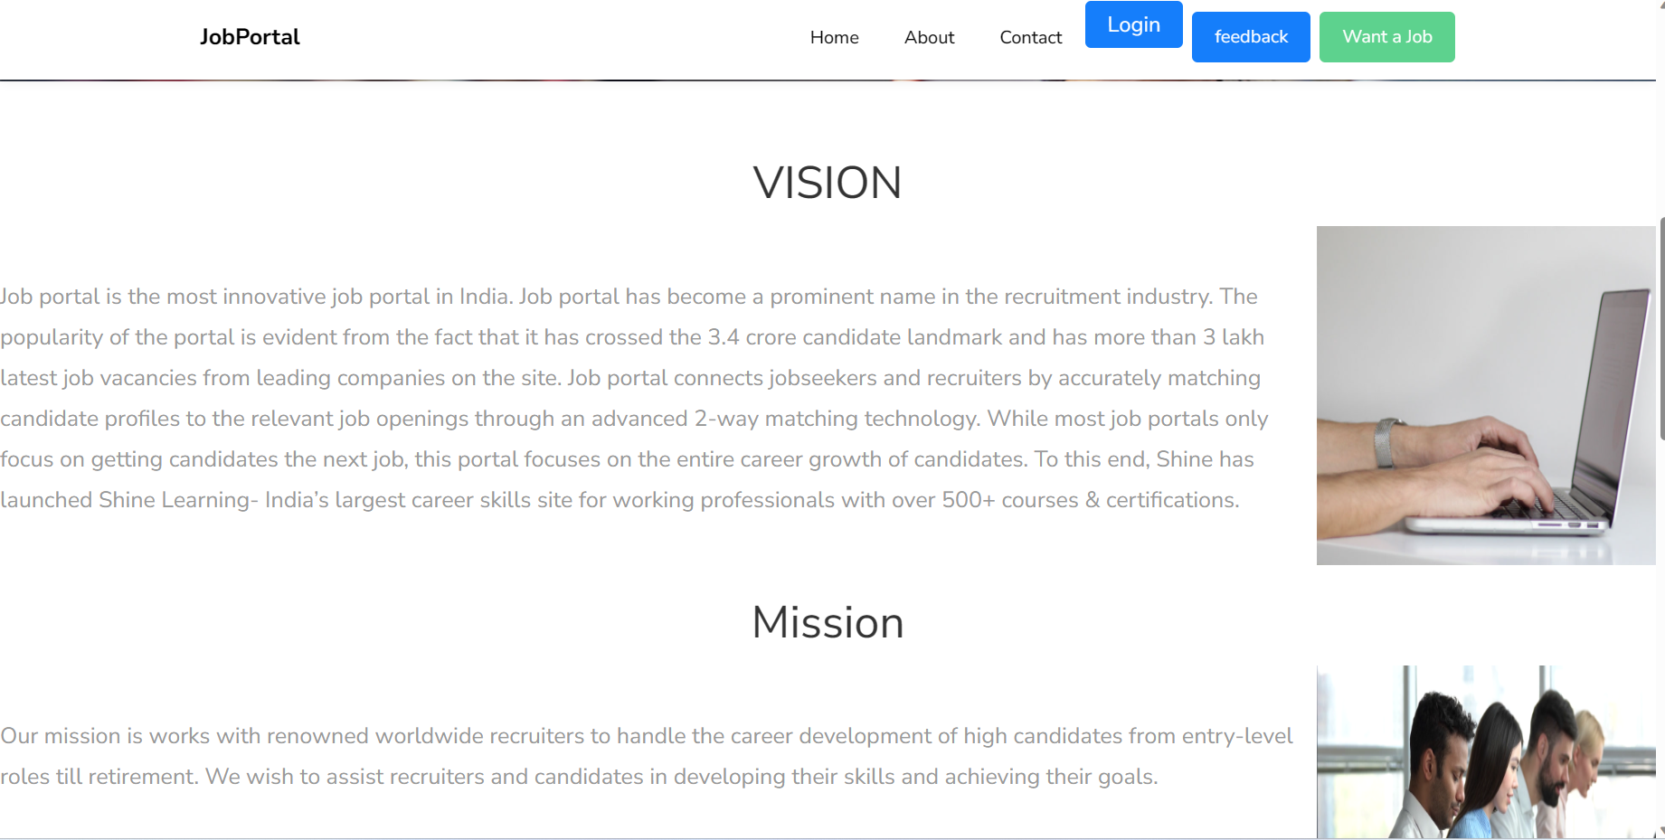

**CONTACT US**

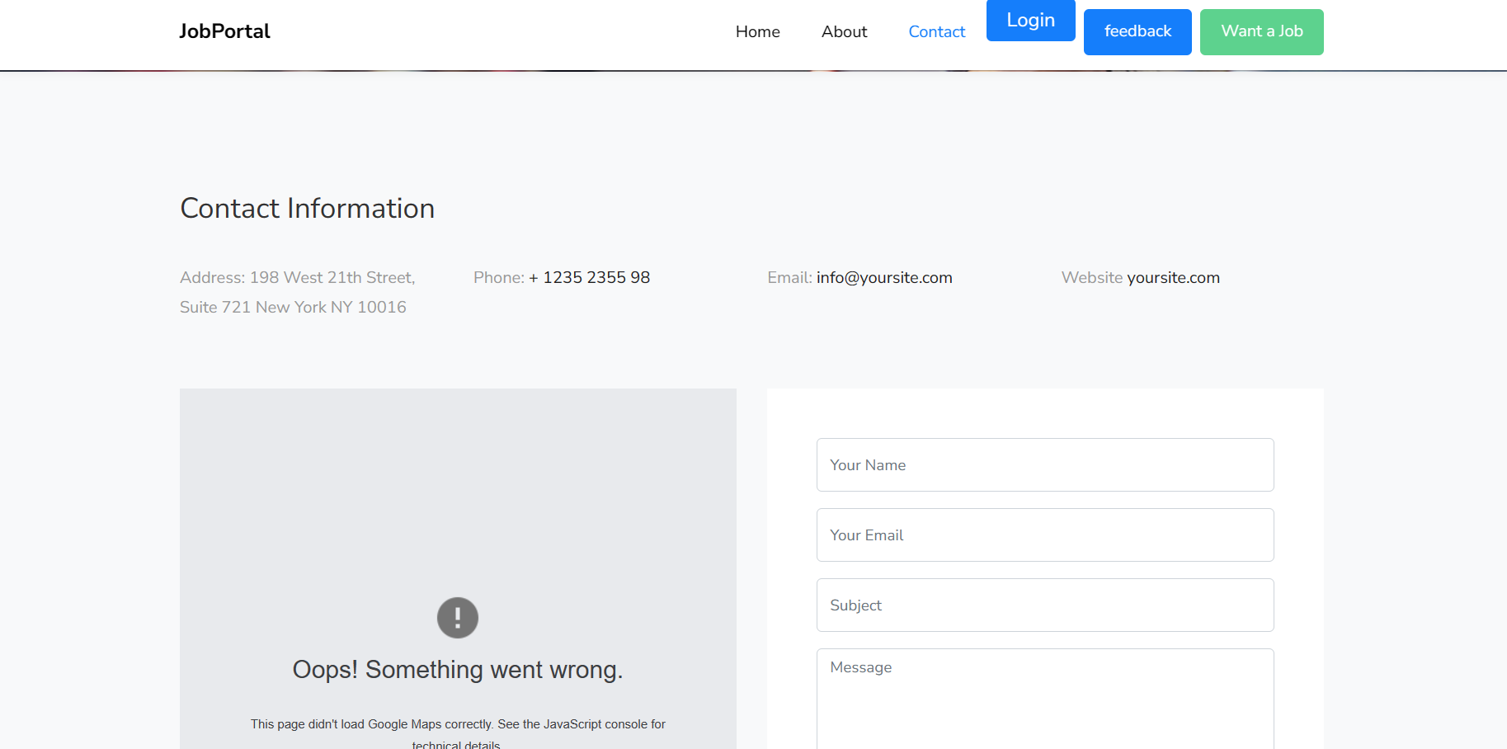

**FEEDBACK**

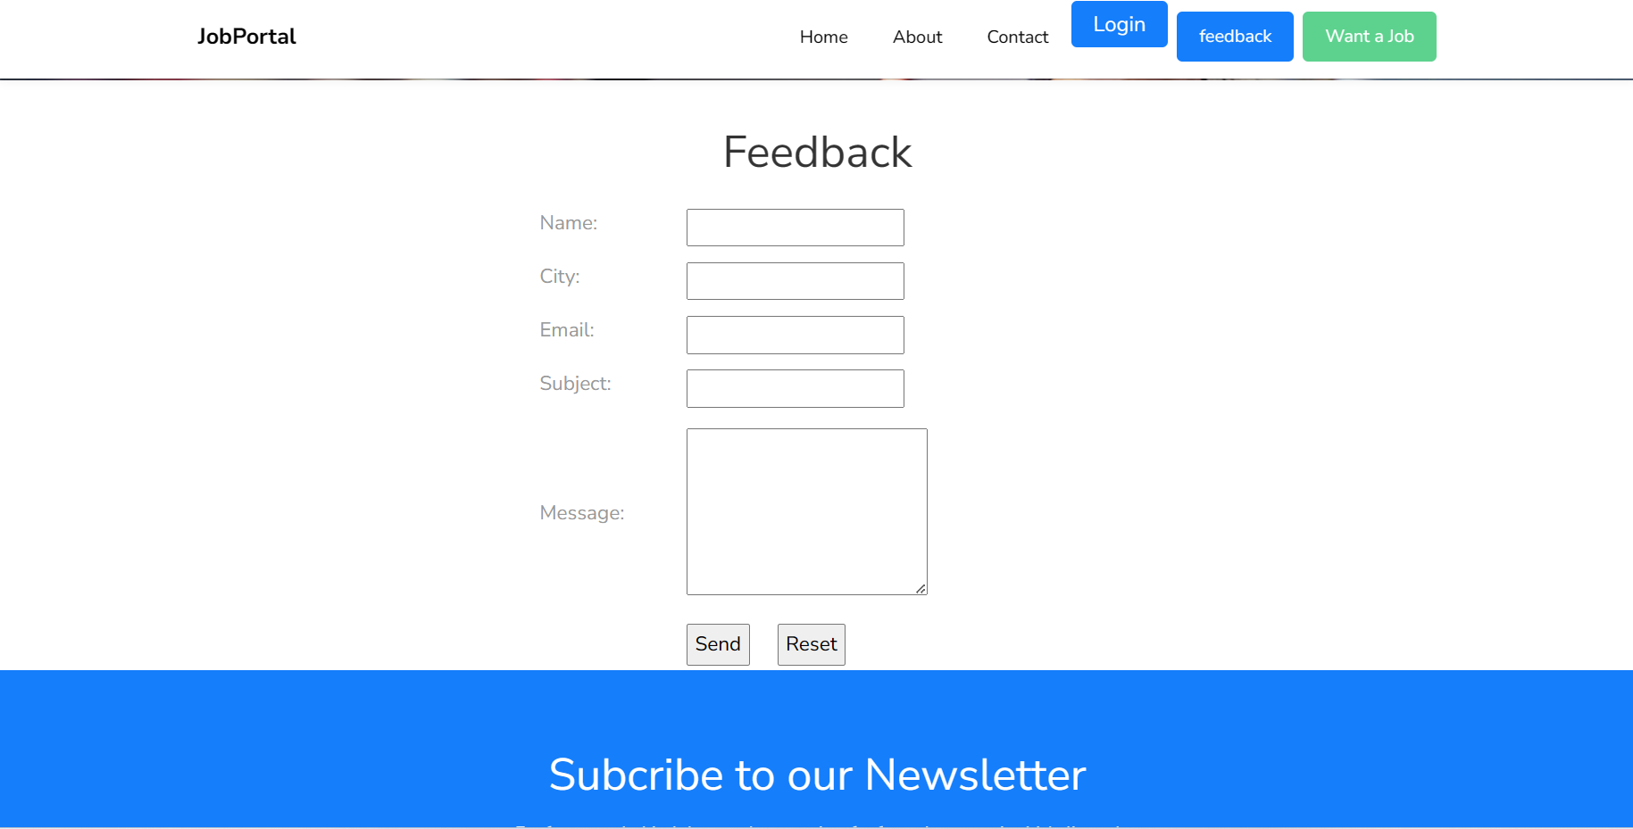

**Task: 3** Login Form

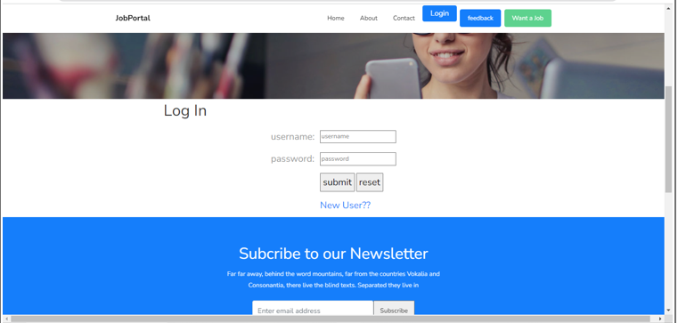

**Task:4** Registration

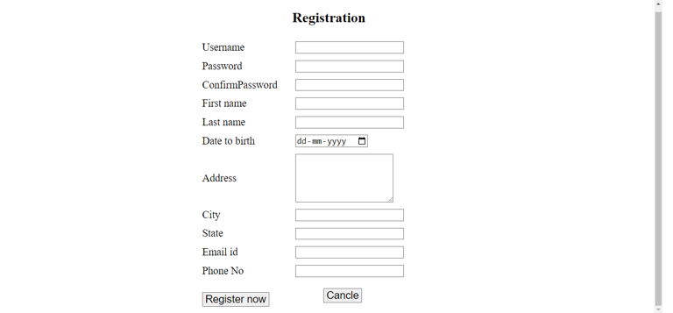

**Task:5** Choose Category/Want a job

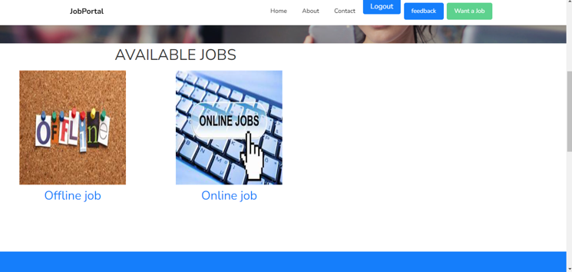

**Task:6** Choose item of Subcategory

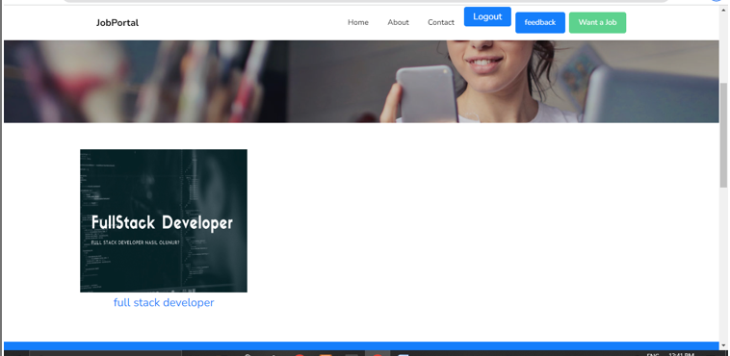

**Task:7** Choose Product

**Task:8** Done table

**Admin Site**

**Task:1** Login in admin site

**Task:2** Category Page

**FEEDBACK**

**USER DETAIL**

**CONTACT DETAIL**

**System Testing**

The important and essential part of system development phase. After designing and developing the software is system testing.

We can not say that every program system is perfect because of luck of communication between the user and the software development.

This is a time when all the system are gather into are gathered into one pool and test whole system to determine wherever it meets the user requirements.

Testing is important function to the success of the system.

There are three techniques of software testing:

**White Box Testing:**

This type of testing required the knowledge of internal structure of software which is clearly visible to programmer so it is known as White Box Testing.

This is also known as Glass Box, Structured Clear Box and Open Box Testing.

White Box System Testing is performed by development team and programmer.

**Black Box Testing:**

This method is named black box because the software programmer in the eyes of the tester is like a black box , inside which are cannot see.

It is also called behavior / functional testing.

It is performed by software engineers.

Tester compare real output with the expected output per success of testing process.

**Grey Box Testing:**

Grey Box Testing is combination of Black Box Testing and White Box Testing.

It is also known as Translate Testing.

**Manual Testing:**

Manual Testing is process which is done manually.

All the famous phase of STLC like test planning , test deployment , result analyses , test execution , buy tracking and reporting tools are obviously coming under the category of manual testing and done successfully by human efforts.

Manual Testing is a start of testing without this testing we cannot start automation testing.

In normal testing we find more buss than automation by error quashing.

It takes lots of time.

Manual Testing would be run sequentially.

Regression Testing process is though in Manual Testing.

It is not expensive.

More testers are required is in manual testing because in this test

need to be executed manually.

It gives low accuracy result.

It is consider as low quality.

In this testing we cannot do batch testing.

It is considered as less reliable.

No need of programming in manual testing.

It is dine without interaction of any tool.

**Automation Testing:**

Automation Testing is process which is done by the help of automated tools.

In automation Testing all the popular phase of SDLC are none by various open source and purchased tools like selenium

1 meter, QTP, Load Runner with Runner and so on.

Automation Testing is continuous part of Manual Testing.

In Automation Testing we test the relative functionalities of the Application.

It takes less time.

It is done on different machines at same time.

Regression Testing process is easy in Automation Testing by tools.

It is expensive.

Few testers are required in Automation Testing because this testing test case need to be executed by using automation tools.

It gives high accruals result.

It is consider as high quality.

In this testing we can do multiple types of Batch Testing.

It is consider as more reliable.

Need of programming is must in Automation Testing.

It is always done using tools.

**ADVANTAGES**

* You can target a big number of the audience if you use an online job board for posting job ads. They attract numbers of candidates every month, so advertising your job online and touching a large number of candidates across the whole world with your job posts which couldn't be easier earlier!
* Finding suitable candidates can be a certain advantage to using an online job platform as you will reach a large section. You can add filter screening inquiries to your applications to guarantee only the most relevant candidates are applying to your postings. The irrelevant candidates will not come to waste your time.
* The portals are accessible 24 hours of the day, and every day wherever you may be. Hence, it is benefiting the candidates the most. Now they don't have to wait till Monday to ring up and apply. Free job posting in India are guaranteeing a much higher acknowledgement rate to your vacancies.
* As mentioned before, when you are recruiting for a vacancy, you may pay large amounts to a recruitment agency to hunt for one specific candidate for you. However, when you post a job online at an online job platform, fees are remarkably affordable, and outcomes are worth the money.

**Disadvantage**

* Using an online job portal with such big amount of job seekers registered there means you are getting read by many. When you post a job, you could receive large number of unwanted applications that will only waste your time. However, you can opt for some filter questions meaning relevant candidates will be filtered through straight to your inbox.
* Unfortunately, not every job post online will be successful. You may not fill your vacancy if not done properly. However, if you ensure that you are selling the job opening to the job seekers, giving particulars of daily tasks and responsibilities along with possible perks of the job; then you will ensure candidates are more eager to apply for your company only.

**FUTURE ENHANCEMENT**

* The job boards have to keep up with the shift in consumer base and market demands. There has been a significant change happening in the digital platform in terms of the content the generation consumes and demands due to differences in political, technological, and economic points of view. Therefore, the job boards must focus on offering value propositions that are quite different and relevant as well.
* Recruiters and job seekers are experiencing an entirely automated process of searching and connecting. All job boards should be perfectly indexed, highly responsive, and exhaustive in job descriptions to establish their credibility and reliability. These features can be clubbed with technical upgrades like job tags supported with search engine optimisations and resume-matching criteria that are need of the hour.

**REFERENCE**

* **WEBSITES:**

[**WWW.APACHE.COM**](http://WWW.APACHE.COM)

[**WWW.PHPMYADMIN.COM**](http://WWW.PHPMYADMIN.COM)

* **REFERENCE:**

[**WWW.LINKED.COM**](http://WWW.LINKED.COM)

[**WWW.NOKRI.COM**](http://WWW.NOKRI.COM)

* **SEARCH ENGINES:**

[**WWW.GOOGLE.COM**](http://WWW.GOOGLE.COM)**.**

[**WWW.EDGE.COM**](http://WWW.EDGE.COM)**.**